SAILING INSTRUCTIONS (SI)
45th SINGAPORE OPEN WINDSURFING, WIND & WING FOILING CHAMPIONSHIP 2026
12th February to 15th February 2026

Venue:
Constant Wind Sailing Centre (CWSC), Singapore
11, Changi Coast Walk, Singapore 499740

Organized by:

Windsurfing Association Singapore (WAS)  in co-operation with Singapore Sailing Federation

Sponsored by  Co-sponsored by 

RULES
1.1 The event will be governed by the rules as defined in 2025 -2028 Racing Rules of Sailing (RRS).
1.2 Unless over-written in this Sailing Instructions, RRS Appendix B will apply for IQ Foils, Techno, and LT classes, and APPENDIX WF WINGFOILING RACING RULES shall apply for Wing Foils
1.4 No national authority prescriptions will apply.
1.5 In all rules governing this regatta:
[DP] The penalty for a breach of the class rules may, at the discretion of the protest committee, be less than a disqualification.
[NP] denotes that a breach of this rule will not be grounds for a protest by a board. This changes RRS 60.1.
1.6 [NP] The infringement of RRS Appendix G, IDENTIFICATION ON SAILS, shall not be grounds for protests by a board.
1.7 If there is a conflict between a rule in the Notice of Race (NoR) or Rules of Racing ( RRS) and a rule in the Sailing Instructions (SI), the rule in the SI (including amendments) will take precedence.
1.8 If there is a conflict between languages, the English text will take precedence.

2 [DP] [NP] ADVERTISING AND ADDITIONAL IDENTIFICATION

2.1 Event branding (Tshirts) shall be worn during media interviews and during the prize giving.
2.2 Event stickers shall not be cut, trimmed or modified in any way.

3 NOTICES TO COMPETITORS
3.1 | The Official Notice Board will be online at:  https://www.racingrulesofsailing.org/documents/13745/event  All links on this page that open to subsidiary pages of the event are also a part of the Official Notice Board.
3.2 | [NP] Supplementary physical notice boards are available at Constant Wind Seasports and official WAS and SSF website. Failure to post on the supplementary notice board will not be grounds for redress. This changes RRS 61.4 (b)(1).
4 | CHANGES TO SAILING INSTRUCTIONS
 | Any change to the SIs will be posted no later than one hour before the warning signal of the race on the day it will take effect, except that any change to the schedule of races will be posted on the day before (11.59pm) it will take effect.
5 | SIGNALS MADE ASHORE
5.1 Signals made ashore will be displayed on the flag staff located within the compound of Constant Wind Seasports Centre.
5.2 When AP flag is displayed on ashore, races not started is postponed.
5.3 [DP] [NP] When AP flag on shore is lowered and Flag D is displayed ‘The warning signal will be made not less than 20 minutes after Flag D is displayed. Boards shall not launch until this signal is made.’
5.4 When displayed AP flag on the committee boat is removed, the next signal will be made not less than 1 minute after its removal.

6 FORMAT OF RACING
6.1 The event will consist of single Series for each class.
6.2 Classes will race separately.
6.3 Men and women from the same class will race together.

7 SCHEDULE

7.1 For Techno 293, Techno 293 Plus, IQ Foil (U17, U19 and Open)

Date | Time | Event
11th Feb (Wednesday) | 1200- 1600 | Registration & Equipment Inspection Self-Practice
12th Feb  (Thursday) | 1000-1030  1130 | Coaches and Skipper’s Briefing  First possible warning signal
13th Feb  (Friday) | 1030 | First possible warning signal
14th Feb  (Saturday) | 1030 | First possible warning signal
15th Feb  (Sunday) | 1030  1600  1800 | First possible warning signal  Last possible warning signal  Prize Giving & Farewell Dinner, Venue: Constant Wind

7.2 For Wing Foil and Windsurfer LT Classes

Date | Time | Event
13th Feb  (Friday) | 1200 - 1600 | Registration & Equipment Inspection Self-Practice
14th Feb  (Saturday) | 1000 -1030  1130 | Skipper’s Briefing  First possible warning signal
15th Feb  (Sunday) | 1030  1600  1800 | First possible warning signal  Last possible warning signal  Prize Giving & Farewell Dinner, Venue: Constant Wind

7.3 [NP] The maximum number of races per day and the maximum number of races per series for each class shall be as follows:
Class | Max number of races per day | Max number of races per series | Remark
Techno 293 & 293  Plus | 4 | 15 | Race starts from  12/2/2026 to  15/2/2026 (4 days)
IQ Foil – all divisions | 10 | 30 | Race starts from  12/2/2026 to  15/2/2026 (4 days)
Wing Foil | 10 | 15 | Race starts from  14/2/2026 to  15/2/2026 (2 days)
Windsurfer LT | 4 | 8 | Race starts from  14/2/2026 to  15/2/2026 (2 days)

8 CLASS FLAGS
8.1 For Techno 293, 293+, Windsurfer LT, Class flags will be displaying the official class logo/insignia
8.2 For IQ Foil and IQ Foil U17 & U19, the official IQ Foil Class Flags will be used
8.3 For Wing Foil, a flag with the alphabet ‘WG’ will be used

9 RACING AREA

9.1 The racing area is at the sea off the National Sailing Centre (Area A) and off Constant Wind (Area B) as illustrated below.

9.1.1 Area A is for Wing Foil, IQ Foil U17 &U19 and IQ Foil classes

9.1.2 Area B is for Techno and Windsurfer LT classes

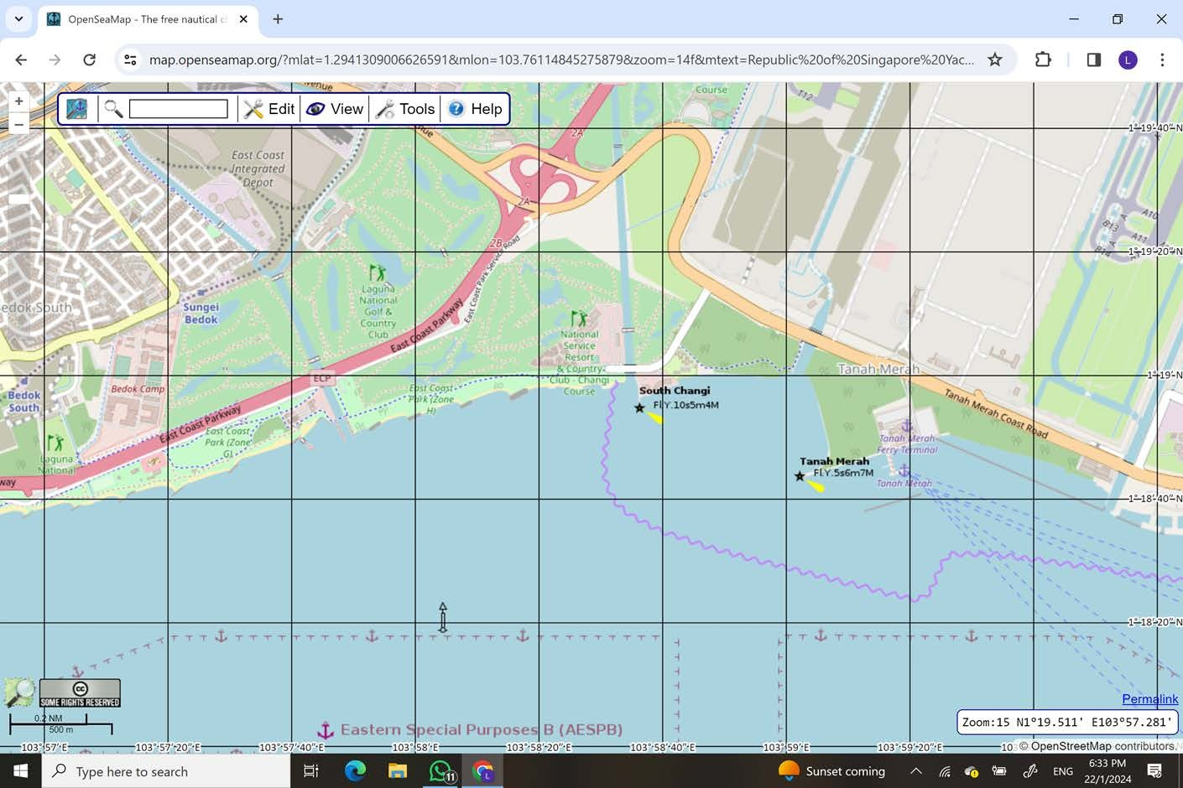

Note:
NSC – National Sailing Centre
CW – Constant Wind Sea Sports Centre
Area

A

Area

B

CW

NSC

10 THE COURSES

The Courses that will be set are shown in Appendix A & B. Information including the course layout, the course signals, and the order in which marks are to be passed are presented.

11 MARKS
11.1 The marks used in Course Racing, Slalom Downwind, Slalom Race and Sprint Slalom Race for Course A can be found in Appendix A
11.2 The marks used in Course Racing for Course B can be found in Course Layout in Appendix B

12 THE START

12.1 Starting Procedures shall be as follows, this changes RRS Part 3, 26:

Minutes before Starting Signal | Visual Signal | Sound Signal | Meaning
3 | Class Flag Displayed  Course Flag Displayed | One | Warning Signal
2 | Preparatory Flag Displayed | One | Preparatory Signal
1 | Preparatory Flag Removed | One long | One Minute Signal
0 | Class Flag Removed | One | Starting Signal
Note:
- The Course and Class Flags displayed for Classes IQ Foil, IQ Foil U17 & U19, Wing Foil and race format can be found in Appendix A
- The Course and Class Flags displayed for Classes Techno 293, 293+ and Windsurfer LT and race format can be found in Appendix B

  - The Starting Line for Classes IQ Foil, IQ Foil U17 &U19, Wing Foil will be between the staff displaying an Orange flag on the Race Committee boat and a buoy as indicated in Course layout in Appendix A
  - The Starting Line for Classes Techno 293, 293+ and Windsurfer LT will be between the staff displaying an Orange flag on the Race Committee boat and a buoy as indicated in the Course layout in Appendix B
  - [DP] When a starting sequence is in progress, boards whose warning signal has not been made shall avoid the starting area. The starting area is defined as a rectangle 75 meters from the starting line and marks in all directions.
  - A board starting later than 4 minutes after her starting signal will be scored Did Not Start (DNS) without a hearing.

13 CHANGE OF THE NEXT LEG OF THE COURSE

To change the next leg of the course, the race committee will lay a new mark (or move the finishing line) and remove the original mark as soon as practicable. When in a subsequent change a new mark is replaced, it will be replaced by an original mark.

14 THE FINISH

14.1 The Finishing Line for all Courses will be described in SI Appendix A and SI Appendix B course diagrams

15 PENALTY SYSTEM

15.1 The penalty for a breach of SI 19.3.1 (Check-Out) will result in a 5-point scoring penalty for the next race completed that racing day and the penalty for a breach of SI 19.3.2 (Check-In) will result in a 5-points scoring penalty for the last race completed that racing day. If only one race is completed, failure to comply with SI 19.3 will incur only a 5-points penalty to that race.

16 TIME LIMITS AND TARGET TIMES

16.1 Time limits and target times are in minutes and as follows:
 | Time Limit | First Rounding Mark Time Limit | Finish  Window | Target Time
T293 & 293+ CLASS  LT CLASS | 40 | 15 | 15 | 25
IQ Foil, IQ Foil U17 & U19, WingFoil  (Course Racing – Wind speed > 10 knots) | 20 | 5 | 10 | 15
IQ Foil, IQ Foil U17 & U19, WingFoil  (Slalom Downwind &  Slalom Race – Windspeed > 7 knots) | 10 | 2 | 5 | 5
IQ Foil, IQ Foil U17 & U19, WingFoil  (Sprint Slalom – Windspeed > 7 knots) | 6 | 2 | 3 | 3
16.2 [NP] If no board has passed the first rounding Mark within its time limit, the race will be abandoned.
16.3 Failure to meet the target time will not be grounds for redress.
16.4 Boards failing to finish within the time stated in the Finish Window, after the first board in that class sails the course and finishes, will be scored Did Not Finish (DNF).

17 PROTESTS AND REQUESTS FOR REDRESS

17.1 The protesting board shall inform the race committee of the boat/s being protested at the finishing line immediately after finishing or as soon as practicable after she retires.
17.2 All protest or request for redress shall be done on-line at this link.
https://www.racingrulesofsailing.org/documents/13745/event
Protest for redress or reopening shall be submitted there within the protest time limit.
17.3 For each class, the protest time limit is 60 minutes after the last board has finished the last race of the day or the race committee signals no more racing today, whichever is later.
17.4 Notices will be posted online no later than 30 minutes after the protest time limit to inform competitors of hearings in which they are parties or named as witnesses. Hearings will be held online or in the Jury Room located at the Constant Wind Seasports Centre Conference Room, based on the information provided in the above link (see 17.2)
17.5 Notices of protests by the race committee, technical committee or protest committee will be posted to inform competitors

18 SCORING
18.1 | Scoring will be according to the RRS Appendix B (Windsurfing Fleet Racing Rules), except as amended below for discards.
18.2 | When fewer than 4 races have been completed, a board’s series score shall be the total of her race scores.
18.3 | When 4 to 7 races have been completed, a board’s series score shall be the total of her race scores excluding her worst score.
18.4 | When 8 to 14 races have been completed, a board’s series score shall be the total of her race scores excluding her two worst scores.
18.5 | When 15 or more races have been completed, a board’s series score shall be the total of her race scores excluding her three worst scores.
19 | [DP][NP] SAFETY REGULATIONS
19.1 | A competitor that retires from a race shall notify the nearest committee boat as soon as possible and within the protest time limit
19.2 | Competitors not racing for any of the racing days shall inform the race office.
19.3 | Check-Out and Check-In Procedures:  19.3.1 Before launching on each scheduled racing day, each competitor shall individually Check-Out, by personally signing on the forms provided at the race control station.  19.3.2 Upon returning to shore after racing, each competitor shall individually Check-In, by personally signing on the forms provided at the race control station, as soon as possible but no later than the protest time limit.
 | [DP][NP] EQUIPMENT & REPLACEMENT OF EQUIPMENT
20.1 For IQ Foil, sailors shall use the new standard sail size (8 m for men and 7.3 m for women & Youth)
20.2 Substitution of damaged or lost equipment will not be allowed unless authorised by the technical committee.
20.3 Replacement ashore: Requests for substitution of damaged or lost equipment shall be made in writing on a form available at the race control and delivered there for consideration. Any request shall be made at the first reasonable opportunity.
20.4 Replacement afloat: When an item of equipment is damaged or lost shortly before a race and is replaced, the competitor shall notify the race committee before the warning signal. As soon as practicable after coming ashore and within the protest time limit, the competitor shall comply with SI 20.2 and the replaced item shall be presented to the technical committee.

21 OFFICIAL VESSELS
21.1  21.2 | Race Committee & Safety vessels will display a white flag with letter “A” in black. The Jury vessels will display a white flag with the letter “J” in black.
22 | [DP] SUPPORT VESSELS
22.1 | Support vessels shall be registered with the organising authority (OA) at the race office and shall be required to comply with local legislation. Limited charter may be available.
22.2 | All support vessels shall also clearly display at all times whilst afloat a Green Flag with a letter which will be issued daily from the Race Control.
22.3  22.4 | Support vessels with team leaders, coaches and other support personnel shall stay 100 m outside areas where boards are racing from the time of starting sequence until all boards have finished, or the race committee signals a postponement, general recall or abandonment.  Support vessels with team leaders, coaches and other support personnel must not latch on to the Race Committee boat at all times, and must not obstruct, instruct or provide their unsolicited views to the Race Officer. Should such actions repeatedly occur, the usage of support boat and other privileges may be withdrawn.
23 | [NP] TRASH DISPOSAL
 | Competitors shall not put trash into the water. Trash may be placed aboard support and race committee vessels.
24 | [DP][NP] RADIO COMMUNICATION
24.1 | While on the water, a competitor shall not carry equipment capable of making radio transmissions or receiving radio communications, except for equipment provided by the organising authority. This restriction also applies to mobile telephones.
24.2 | For purposes of safety, coaches may monitor the race committee working channel, but cannot transmit on this channel except in the case of an emergency.
25 | PRIZES
 | Prizes will be awarded according to the information on the Notice of Race.
26 | DISCLAIMER OF LIABILITY
 | Competitors participate in the event entirely at their own risk, see RRS 3 - Decision to Race. The organising authority or any of their officials or representatives or the sponsors or their officials or representatives will not accept any liability for material damage or personal injury or death sustained in conjunction with or prior to, during or after the event.
27 | INSURANCE
Each participating competitor shall have valid third-party liability insurance.

APPENDIX A : Course Racing

Location: Area A

Class: IQ Foil, IQ Foil U17 & U19, Wing Foils
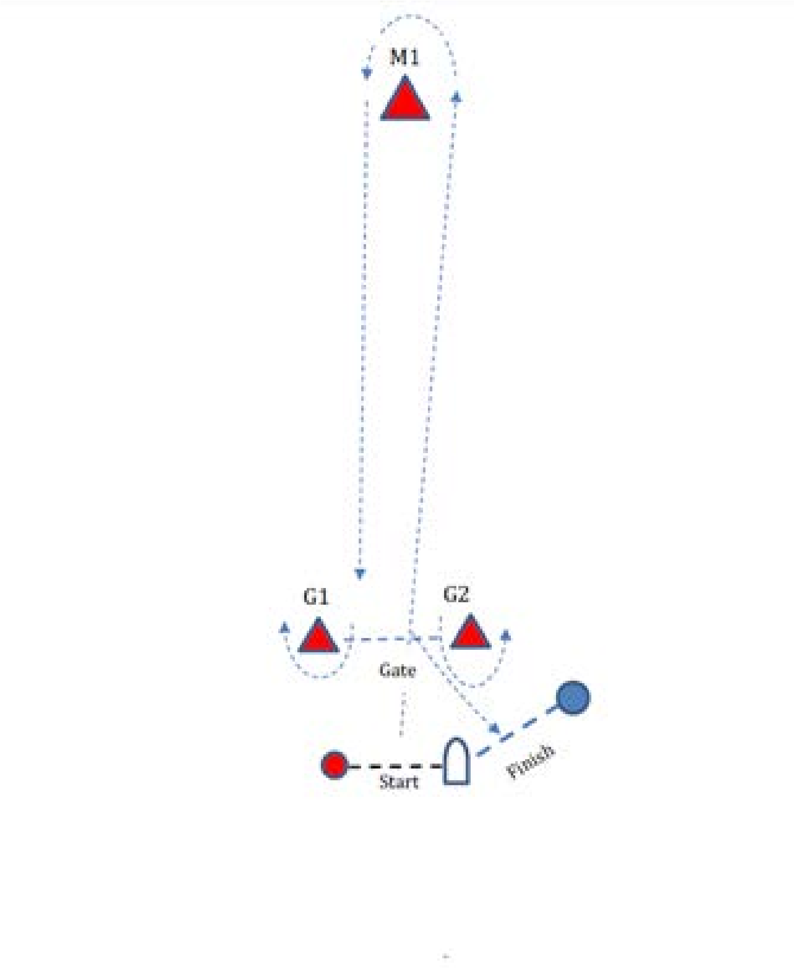

Signal | Marking Rounding Order
Class Flag + Pennant 2 | Start (Boat & Red Spherical Buoy) – M1 – Gate – M1 – Gate – Finish (Boat & Blue Spherical Buoy
Class Flag + Pennant 3 | Start (Boat & Red Spherical Buoy) – M1 – Gate – M1 – Gate – M1 – Gate – Finish (Boat & Blue Spherical Buoy

Mark M1, G1, G2 : Red Triangular buoy

APPENDIX A : Slalom Downwind

Location: Area A

Class: IQ Foil, IQ Foil U17 & U19, Wing Foils

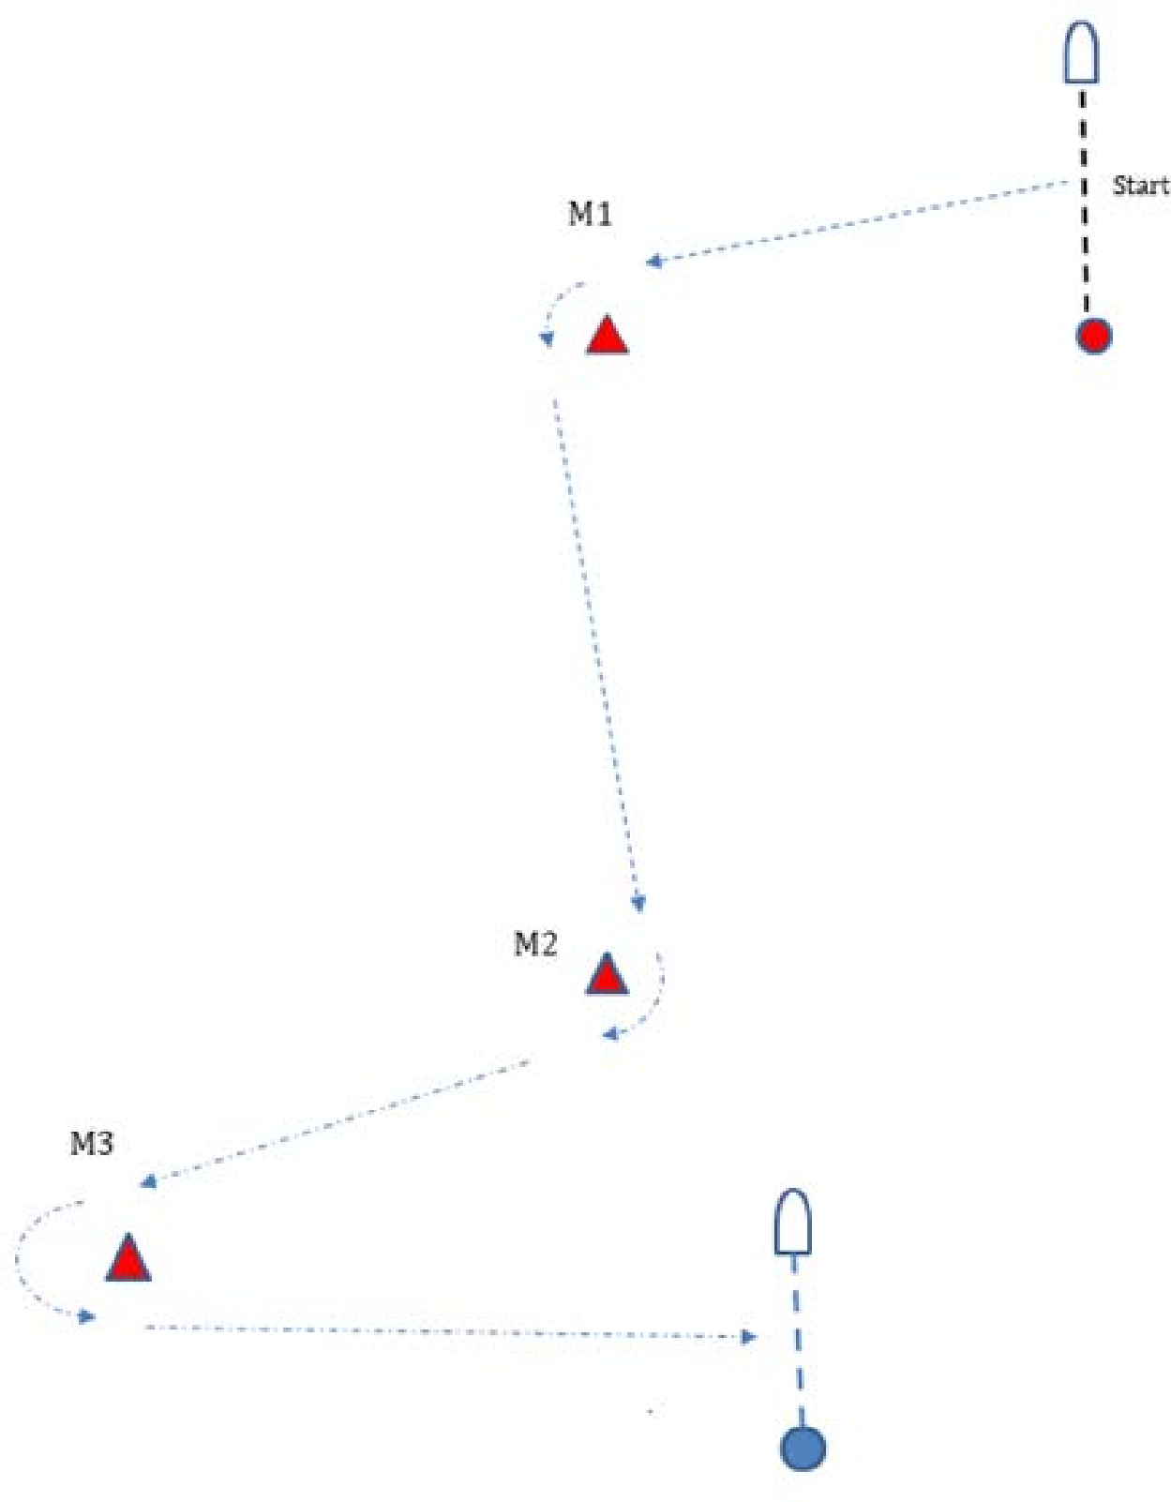
Finish
Line

Signal | Marking Rounding Order
Class Flag + Pennant 4 | Start (Boat & Red Spherical Buoy) – M1 –M2 – M3 – Finish (Boat & Blue Spherical Buoy)

Mark M1, M2, M3: Red Triangular buoys

Appendix A: Slalom Race & Sprint Slalom Race

Location: Area A
Class: IQ Foil, IQ Foil U17 & U19, WingFoil

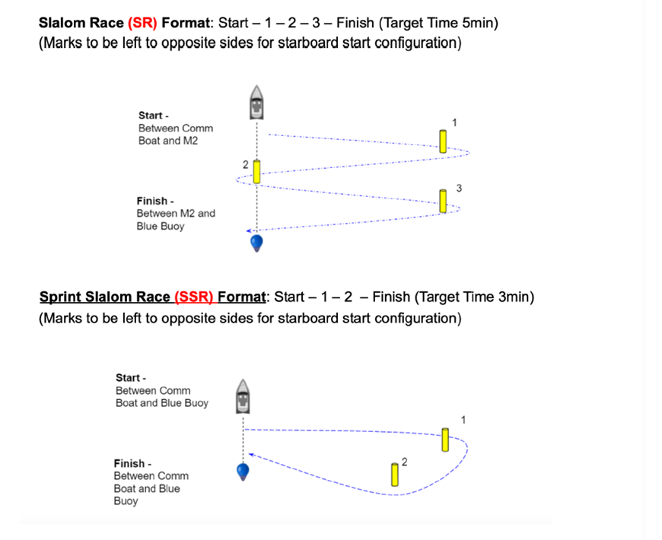

Signal | Marking Rounding Order
Class Flag + Pennant 5 | Start (Boat & M2) – M1 –M2 – M3 – Finish
Class Flag + Pennant 6 | Start (Boat & Blue Buoy) – M1 – M2 – Finish

Mark M1, M2, M3: Red Triangular buoys

Appendix B: Course Racing Location: Area B
Class: Techno 293, 293+, Windsurfer LT



Wind Direction

M1

M2

M3

Start

Signal | Marking Rounding Order
Class Flag + Pennant 2 | Start – M1 – M2 – M3 – M1 – M3 - Finish
Class Flag + Pennant 1 | Start – M1 – M2 – M3 - Finish

Mark M1, M3: Red Square buoys
Mark M2: Green Square buoy

