SIM Windsurfing Championships 2015
* In conjunction with Asian Windsurfing Championships 2015

24th – 25th January 2015
National Sailing Centre
Organising Authority: SIM Windsurfing Club

SAILING INSTRUCTIONS

1 RULES
The races will be governed by the Racing Rules of Sailing 2013-2016 issued by the ISAF, including the Appendix except where amended by the Notice of Race and the Sailing Instructions.
2 ENTRIES
Competitors may enter by completing registration and submitting fees prior to the registration deadline (9th January 2015) as prescribed in the Notice of Race.

3 DISCLAIMER OF LIABILITY
All competitors taking part in this event do so at their own risk and responsibility. Singapore Institute of Management, SIM Windsurfing Club, Windsurfing Association of Singapore, National Sailing Centre, Constant Wind Sea Sports Centre and NSRCC Sea Sports Centre will not be liable for any material damage, personal injury or loss of life in conjunction with, or prior to, during or after the event.

4 EQUIPMENT
4.1 All competitors are to use club equipment provided by NSRCC Sea Sports Centre:
– 6.2m Intermediate Mixed (6.2m Soft Sail and Techno Board)
– 5.5m Intermediate Men (5.5m Soft Sail and Techno Board)
– 4.7m Intermediate Women (4.7 Soft Sail and Techno Board)
– 4.0m Novice Men (4.0m Soft Sail and JP)
– 4.0m Novice Women (4.0m Soft Sail and RRD)

4.2 The use of harness is strictly disallowed in the Race.
4.3 Competitors have to do an equipment check and sail to National Sailing Centre from Constant Wind Sea Sports Centre on the 17th &/or 18th January.
4.4 Allocation of equipment will be through balloting and any request for a change will be subject to approval.

5 NOTICES TO COMPETITORS
Notices to competitors will be posted on the official race notice board along the
corridor next to the race office.

6 CHANGES IN SAILING INSTRUCTIONS
Any changes in sailing instructions will be posted at least 40 minutes before the start of each race on the official race notice board
7 SCHEDULE
7.1 Event schedule
24TH January 2015
0900 – 1000 | Registration and issuing of equipment
1000 – 1030 | Opening of event
1030 – 1045 | Skipper’s briefing
1100 | Start of race
1730 | Last possible start of race
End of day’s racing | Washing and returning of equipment

25TH January 2015
1000 – 1100 | Competitors signing in and rigging up
1100 | Start of race
1700 | Last possible start of race
1730 – 1830 | Washing and returning of equipment/Inspection
1830 – 1900 | Prize presentation ceremony
1900 – 2000 | Event dinner

7.2 Minimum of 1 race to constitute an event. No limit to number of races to be
conducted daily within stipulated times.
7.3 All races will be sailed back-to-back for all categories unless informed by the OD at
the finishing line.
7.4 The warning signal for each succeeding race will be made as soon as practicable
after the finish of the previous race.
7.5 To alert the competitors that a race or sequence of races are about to begin, an
orange flag accompanied by a sound signal will be hoisted at least 5 minutes before
a warning signal is made.

8 RACING AREA
The racing area will be in the waters off NSC.

9 COURSE
Point 22 (Appendix) shows the courses, the course signals, the order which the marks are to be passed and rounded.

10 MARKS
10.1 Marks 1, 2, 3 and 4s/p are buoys. The colour and shape will be posted on the official
notice board.
10.2 New mark will be white spherical buoy.

11 START
11.1 Races will commence by using Rule 26 with the warning signal given 5 minutes
before the starting signal. The starting line will be between the flag mast on the race
committee boat and a pink spherical buoy.
11.2 Competitors whose warning signal has not been made shall avoid the starting area
during the starting sequence of other class.
11.3 A competitor starting later than 4 minutes after her starting signal will be scored Did
Not Start (DNS) without a hearing. This changes RRS A4 & A5.
11.4 The order of the starts will be decided by the race officials.

12 CLASS FLAGS
Class Flag | Description
Pink | 4.0m Novice Men, 4.0m Novice Women
Brown | 5.5m Intermediate Men, 4.7m Intermediate Women
Purple | 6.2m Intermediate Mixed

.

13 SHORTENING COURSE AND CHANGING THE NEXT LEG OF COURSE
13.1 If the S flag is raised before or with the warning signal, competitors shall sail the
short course as shown in Point 22 (Appendix). If the S flag is raised at any rounding
mark during the race, competitors shall finish between that mark and the boat flying
the flag.

13.2 To change the next leg of the course, the race committee will lay a new mark and
remove the original mark as soon as practicable.

14 THE FINISH
The finish line will be between the mast of the committee boat and a blue cylindrical buoy.

15 OTHER SIGNALS
Answering Pennant –
The “AP” flag will be flown on a flagpole on shore. When it is lowered and accompanied by a sound signal, the next race will start in 20 minutes. All competitors will be required to proceed to the start line immediately.

16 RECALLS
Individual recalls and general recalls and re-starts will be made in accordance with Rule 29.

17 TIME LIMIT
The time limit will be 40 minutes for the leading board. Competitors finishing more than 20 minutes after the leading board will be scored “did not finish” (DNF).
18 PROTESTS
The OD shall be informed of the protest at the end of that particular race before lodging a written protest on shore. Protest forms are available at the race office, and must be lodged there within 45 minutes of the last board’s finish. A fee of $10 must accompany each protest.

19 SCORING
The ISAF Appendix “A” Low Point Scoring System will apply.
If 4 or more races are conducted, 1 discard is allowed.

20 SAFETY
20.1 All competitors shall wear a Personal Flotation Device at all times.
20.2 All competitors to personally Sign In against their name prior to launching.
20.3 When returning to shore, all competitors shall Sign Out against their name
within the protest time limit or within 60 minutes of the display of AP/H, AP/A,
N/H or N/A .
20.4 A competitor that retires from a race shall inform the Race committee as soon
as possible and shall fill in a Retirement Declaration form at the race office
within the protest time limit.

21 PENALTIES
21.1 NO PERSONAL FLOTATION DEVICE
Penalty DSQ on the entire day’s racing results or if none has been conducted,
the following day’s entire results.
21.2 NOT SIGNING IN OR OUT, declaring retirement and filling in form.
5 points added for each offence to total score. Non Discardable from overall
results

22 APPENDIX
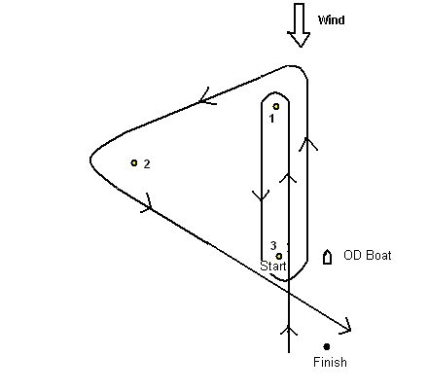

Course A:
Signal | Mark Rounding Order
A | Start → 1 → 3 → 1 → 2 → 3 → Finish

Course A flag will be black bold letter A on white background.

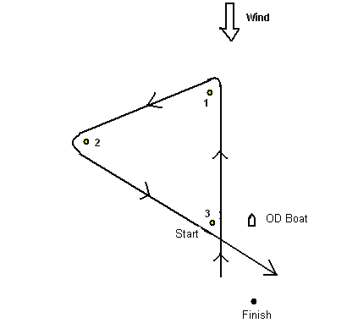

Course B:

Signal | Mark Rounding Order
B | Start → 1 → 2 → 3 → Finish

Course B flag will be blue bold letter B on light shade of yellow background.

